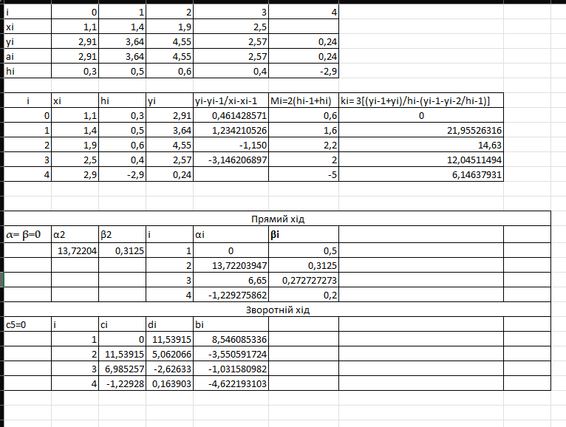

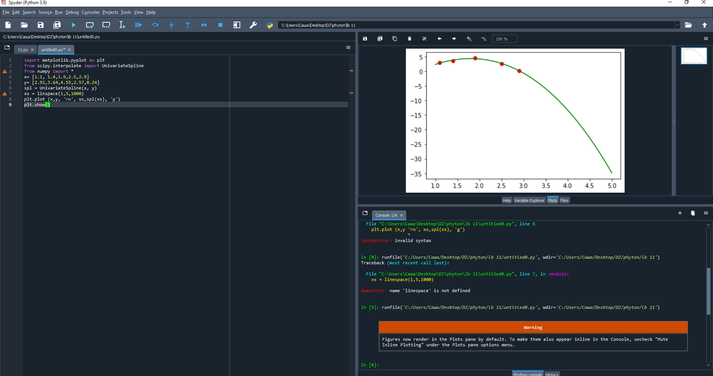

import matplotlib.pyplot as plt

from scipy.interpolate import UnivariateSpline

from numpy import \*

x= [1.1, 1.4,1.9,2.5,2.9]

y= [2.91,3.64,4.55,2.57,0.24]

spl = UnivariateSpline(x, y)

xs = linspace(1,5,1000)

plt.plot (x,y, 'ro', xs,spl(xs), 'g')

plt.show()